UNU-IRADDA Testing – D1

Maintain Proposal | Proposal Definition
Navigation:  Grants > Proposals > Maintain Proposal  Add a new Proposal for UNU-IRADDA  Make a note of the Project ID  *00088116 | 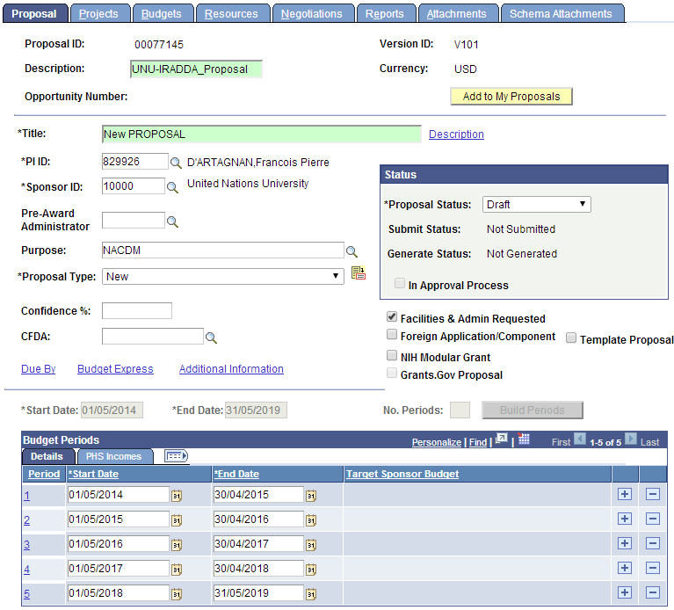  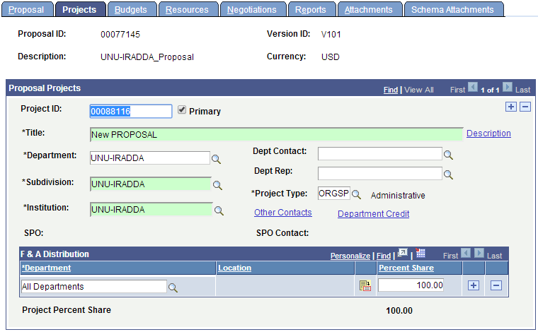
Enter Budget Detail for at least 1 fiscal/budget year | 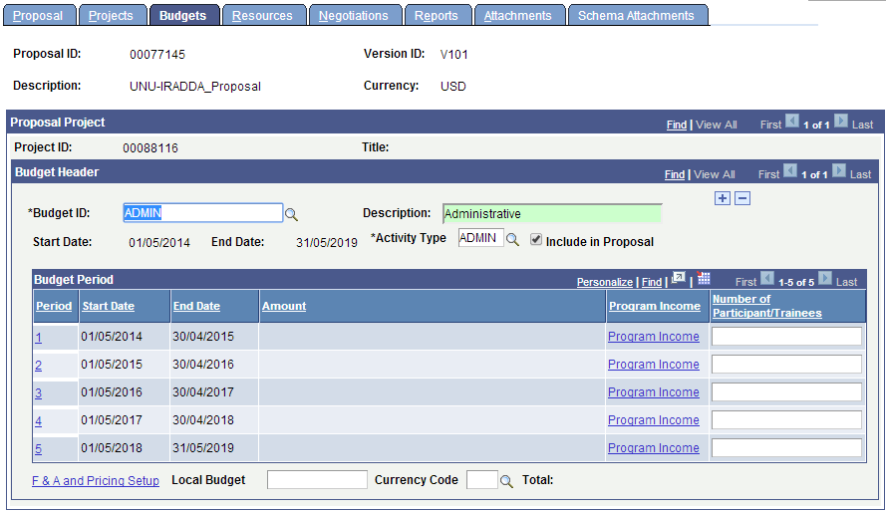  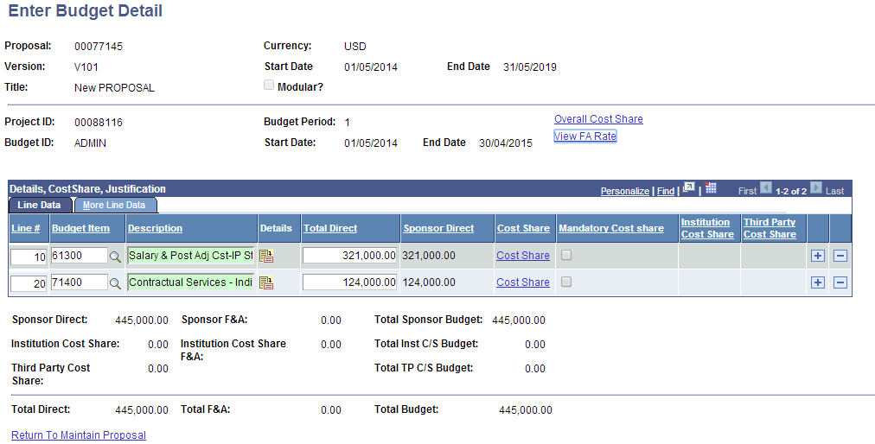  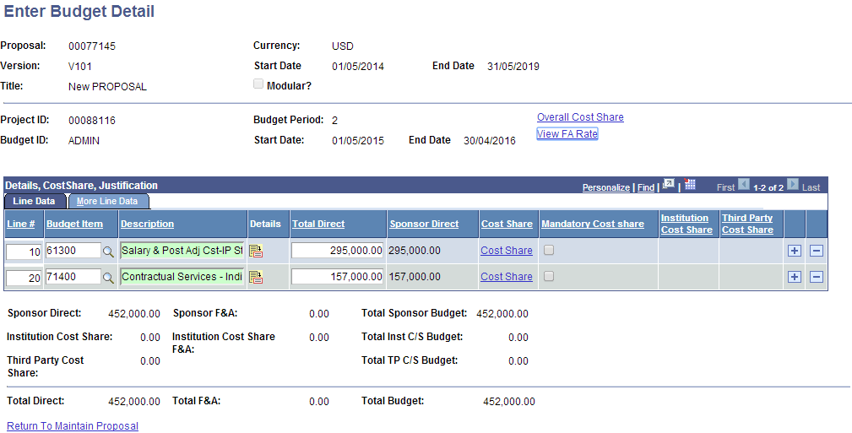

Submit Proposal | Submit Proposal
Navigation:  Grants > Proposals > Submit Proposal | 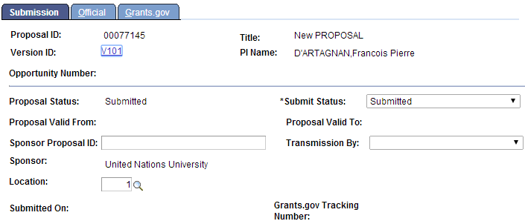

Generate Award | Generate Award
Navigation:  Grants > Proposals > Generate Award | 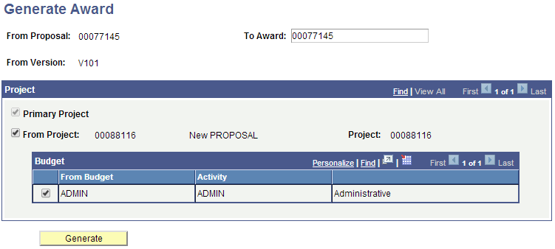

Award Profile | Award Profile
Navigation:  Grants > Awards > Award Profile | 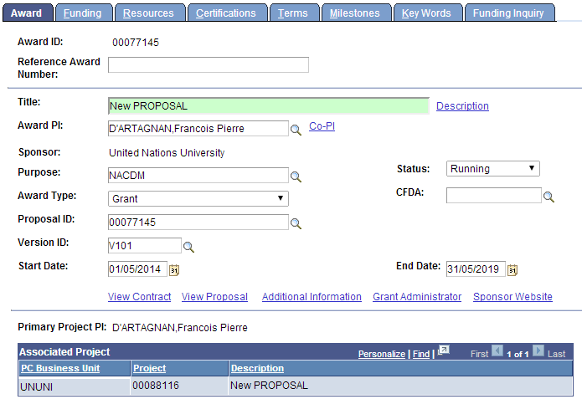  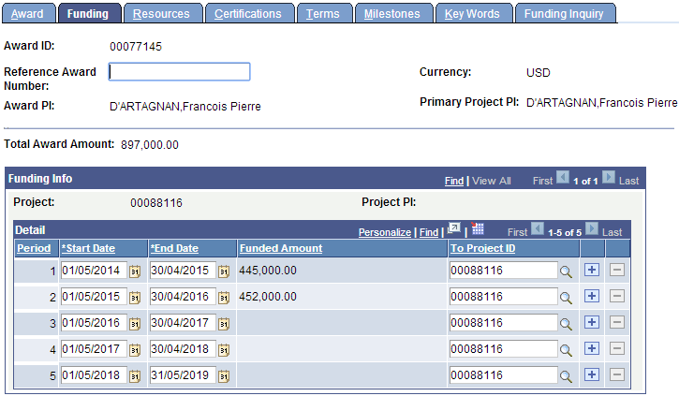

KK Level 1 | Budget Journal
Navigation:  Commitment Control > Budget Journals > Enter Budget Journals  Enter Budget Journal for Budget Period 2014 for Budget Department B0780 | 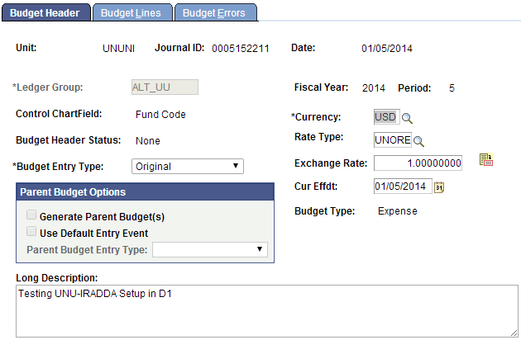  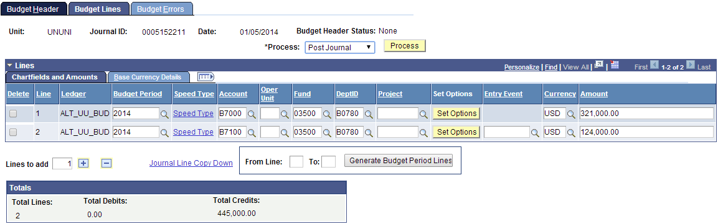  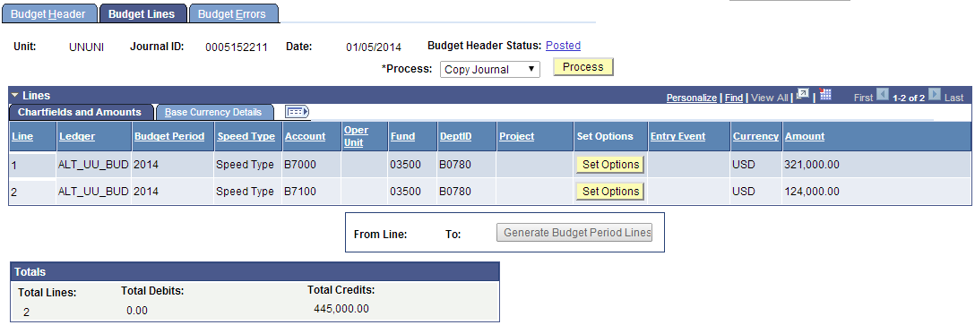

KK Level 1 | Budget Details
Navigation:  Commitment Control > Review Budget Activities > Budget Details  Review Level 1 Budget for B0780 | 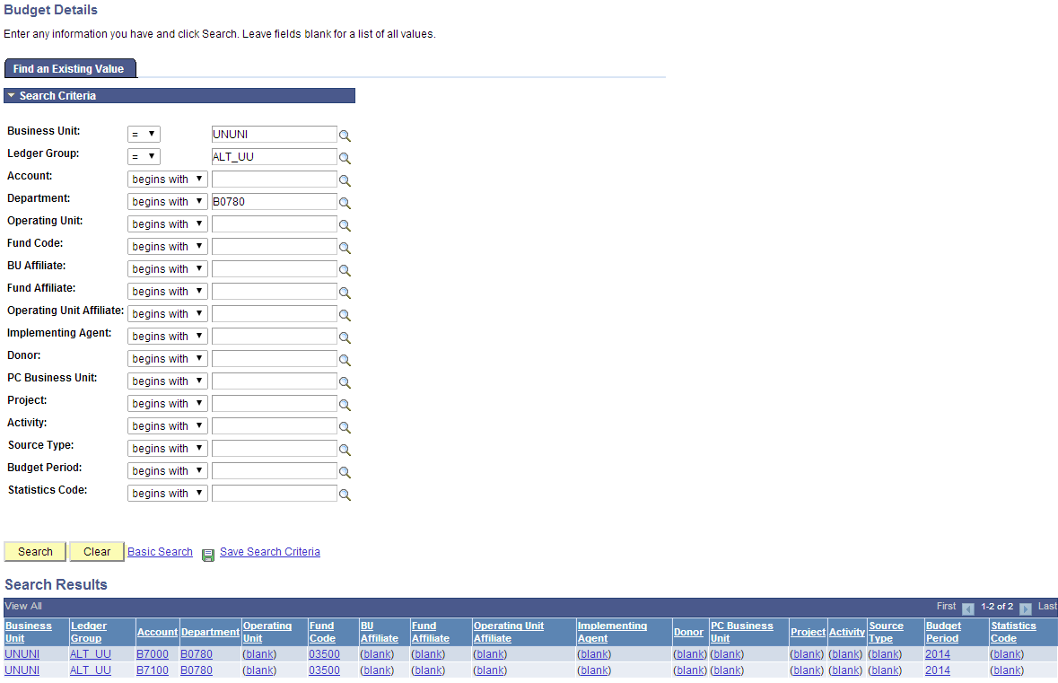  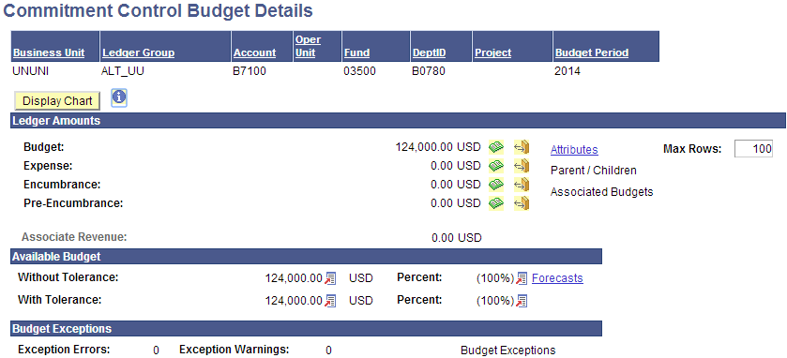  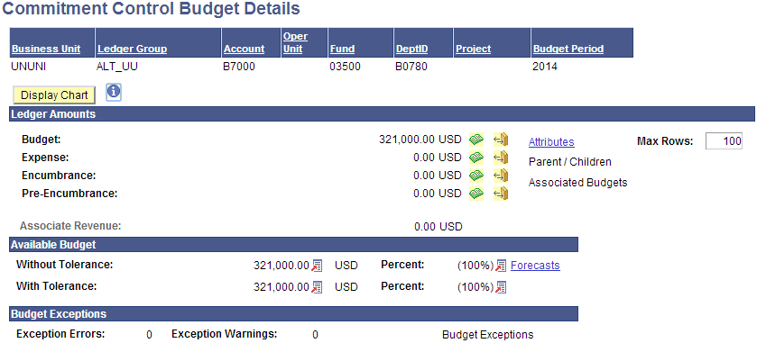

Project Budgets | Finalize Project Budgets
Navigation:  Grants > Awards > Project Budgets  Finalize Project Budgets for Project 00088116 | 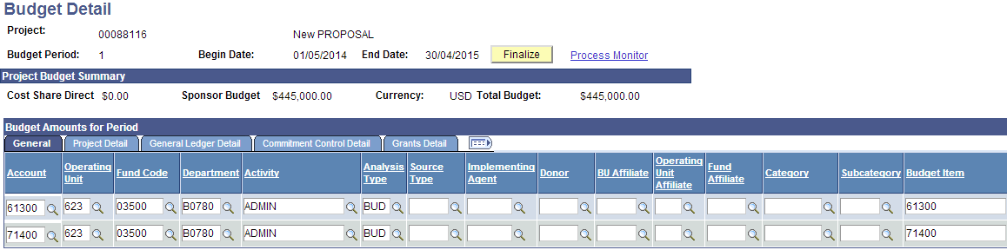  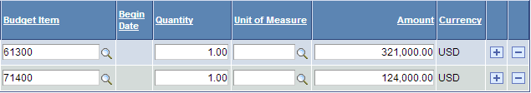  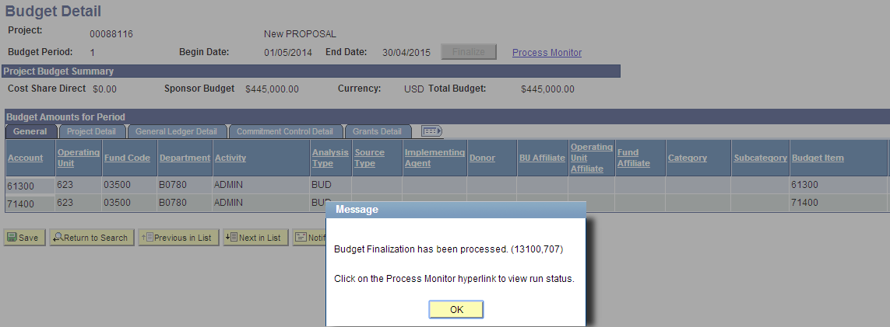  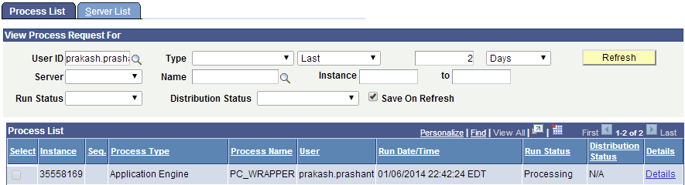  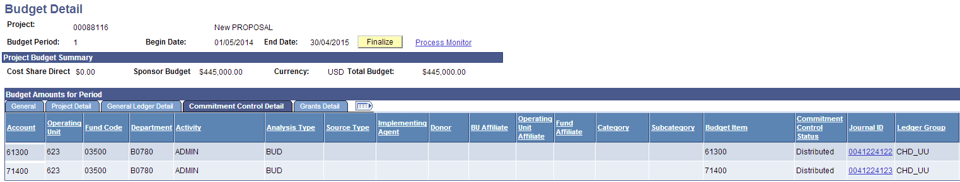

KK Level 2 | Budget Details
Navigation:  Commitment Control > Review Budget Activities > Budget Details  Review Level 2 Budget for Project 00088116 | 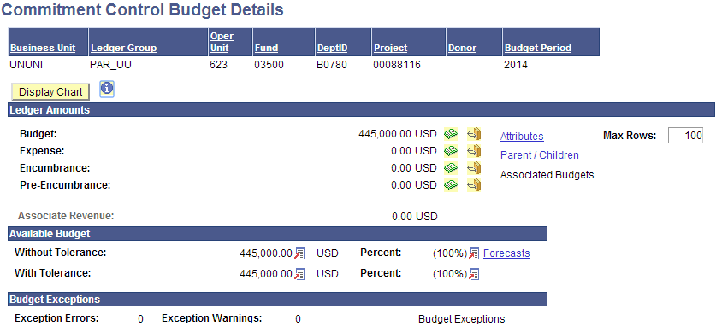

Procurement Contract | Create Contract
Navigation:  Purchasing > Procurement Contracts > Add/Update Contracts  Enter a contract for PO BU 623UU | 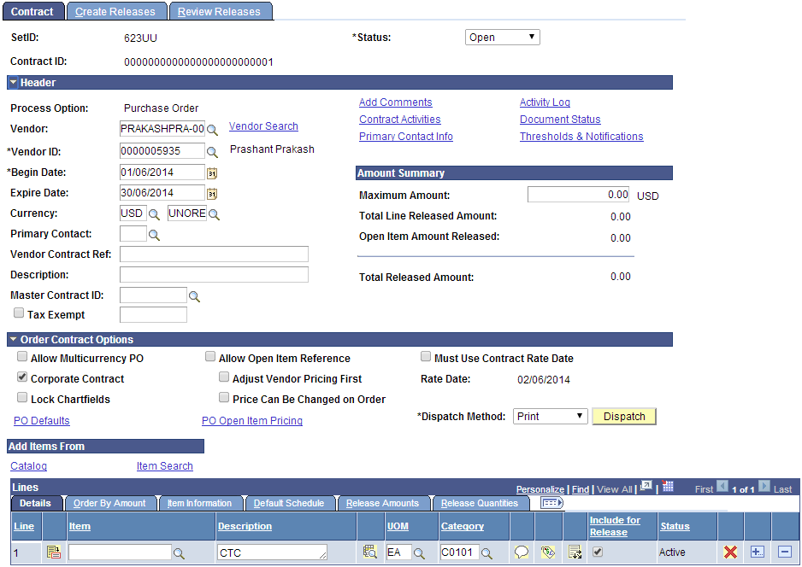
Enter the contract on the Contract for Services Page  Finalize the contract | 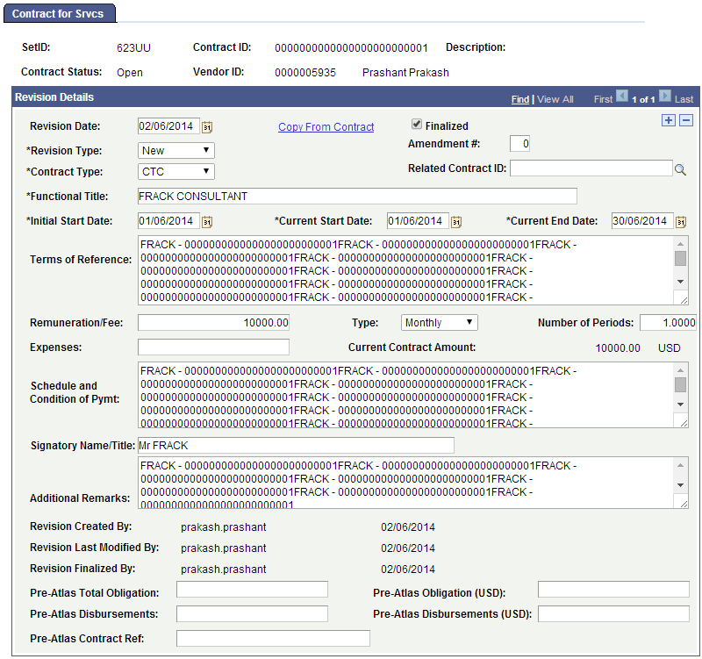
Print the Contract | 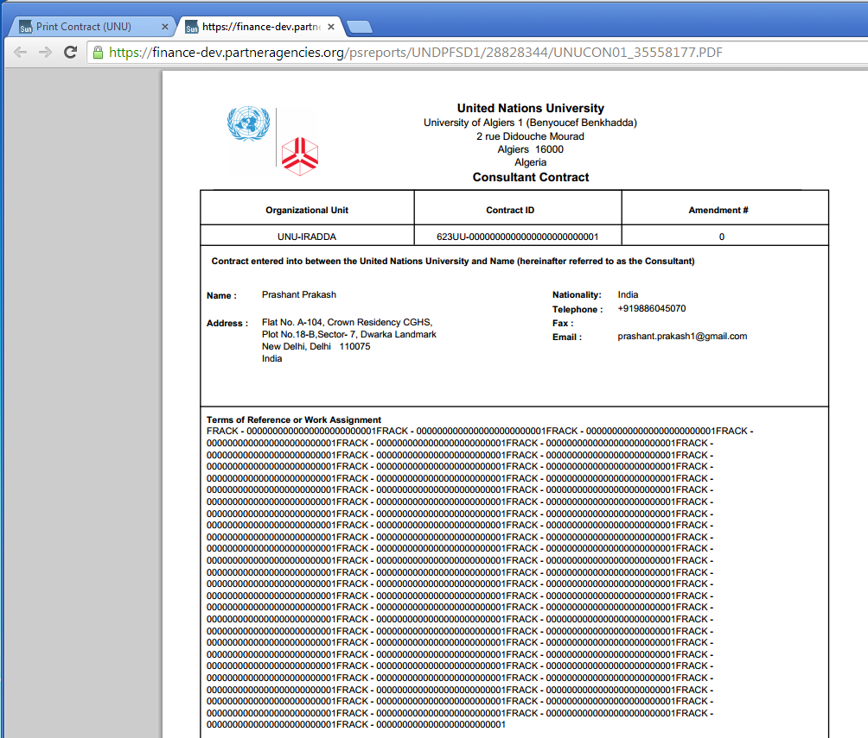
Approve and Stage the Contract | 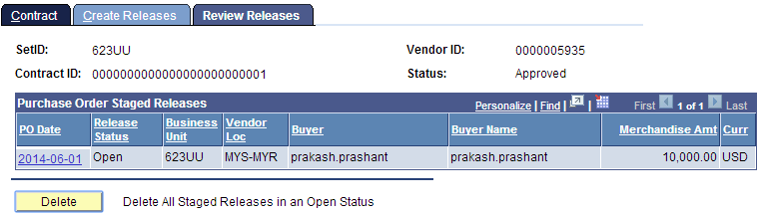
Stage Contract POs  Navigate to the Sourcing Workbench  Note the PO ID | 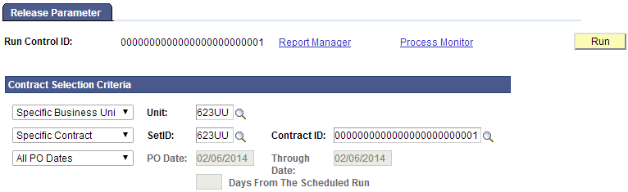  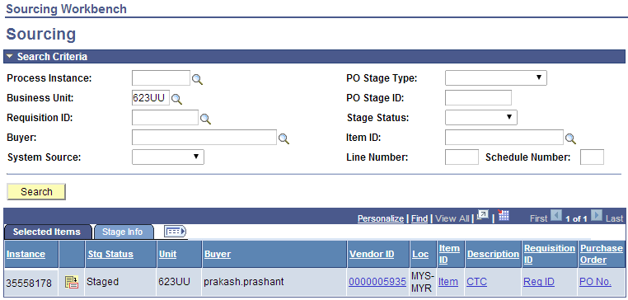  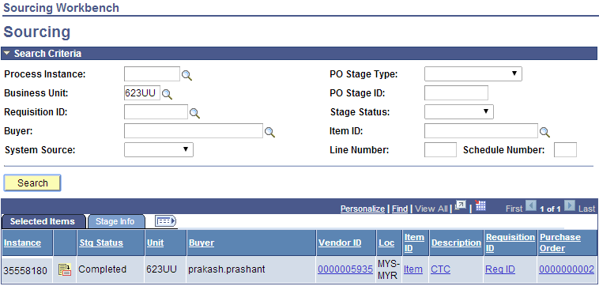
Approve, Budget Check & Dispatch the PO 623UU/#2  Create Receipt for this PO | 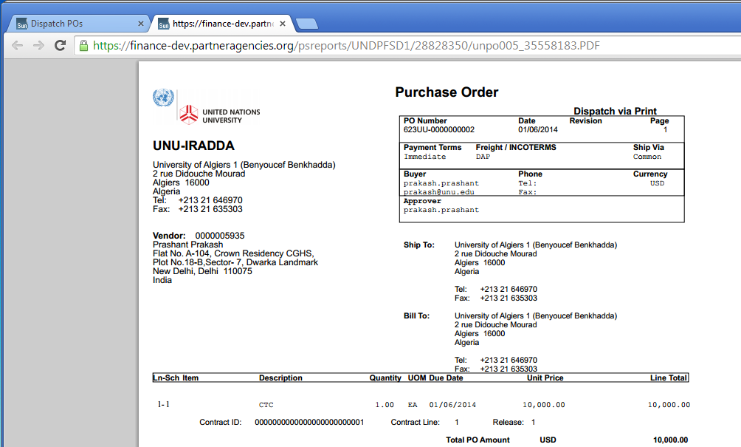  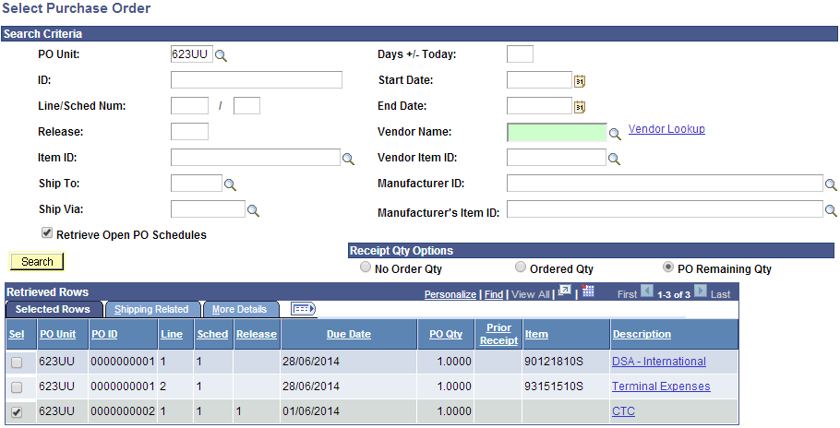  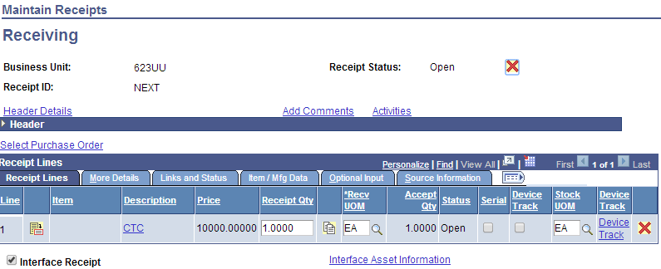
Review Receipt Information | 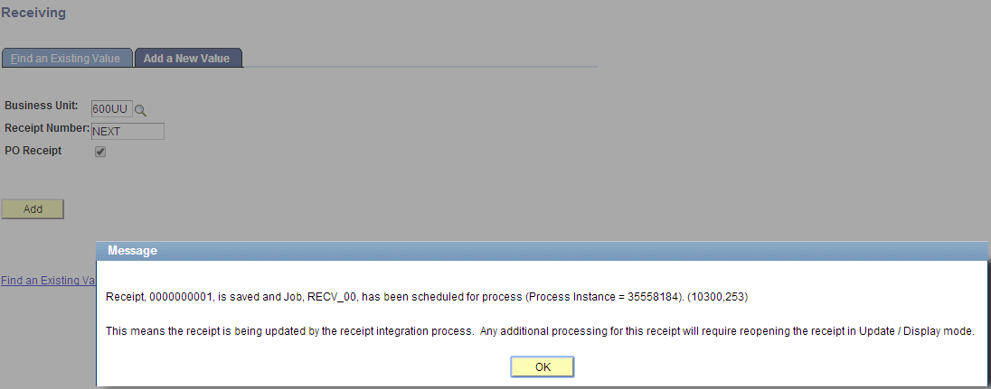  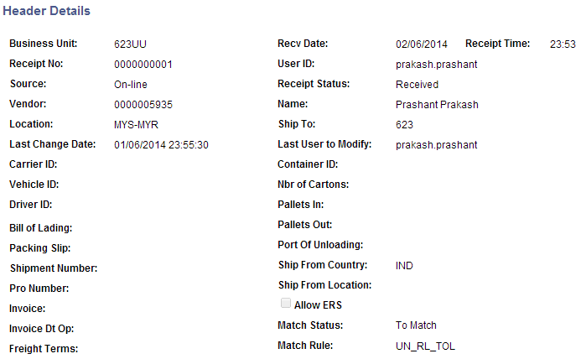
Create Voucher by Copying PO Receipt | 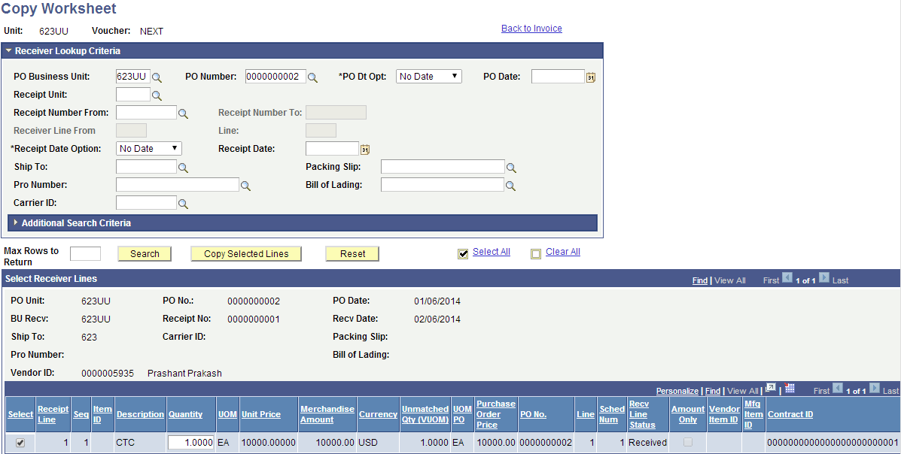  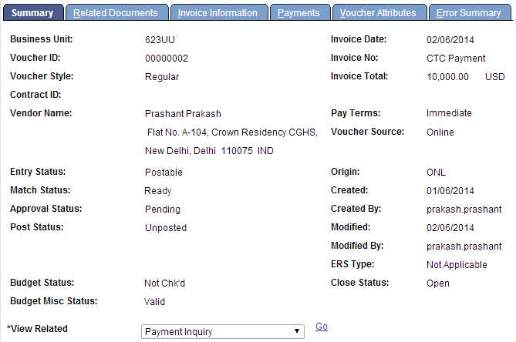  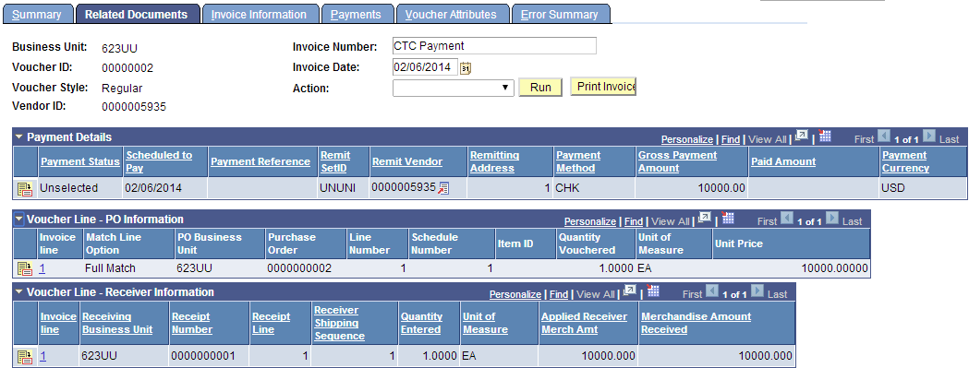
Match the Voucher 623UU/#2 | 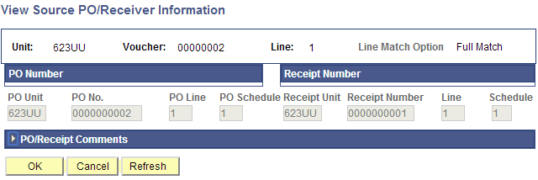  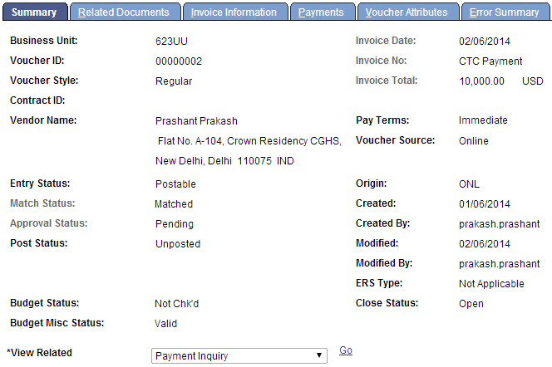  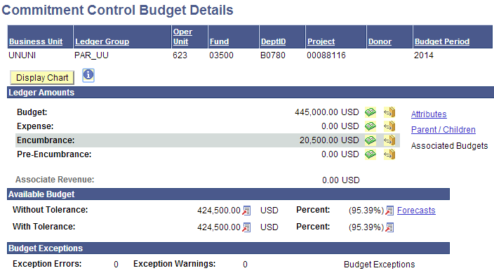

Requisition | Goods/Services Request
Navigation:  Purchasing > Requisitions > Add/Update Requisitions  Create a Goods/Services request under PO BU 623UU | 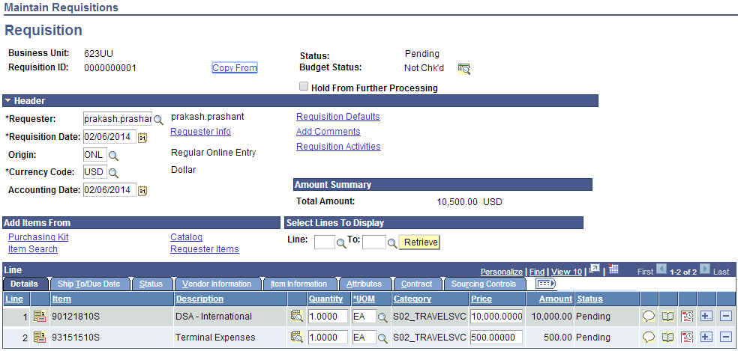  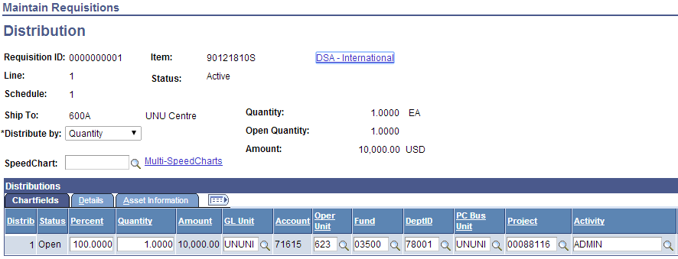  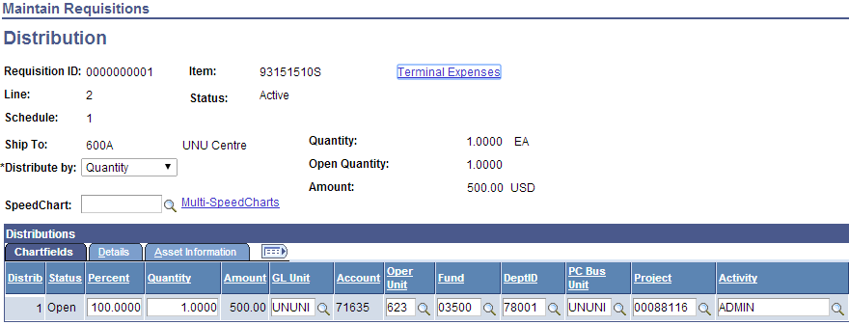
Approve and Budget Check the requisition 623UU/#1  Review Level 2 Project Budgets.  Note the Pre-Encumbrance  Review Level 1 Budget Department Budget.  Note the Pre-Encumbrance  ***Added a Route Control Profile UN_DEPT_UNUNI_B0780  This was needed to test Requisition Approval. Should ideally be created by ARGUS | 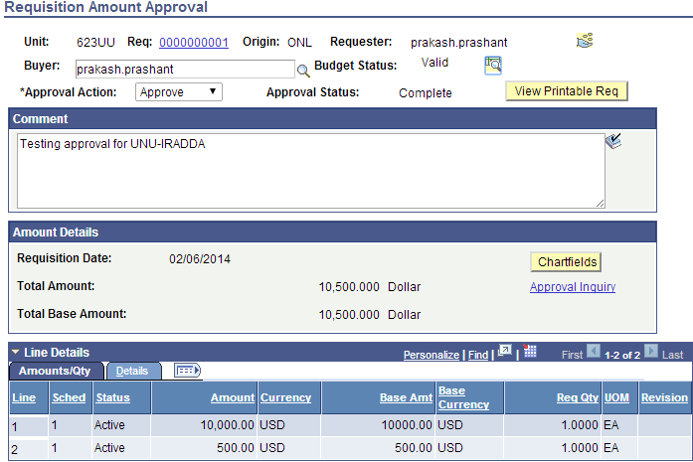  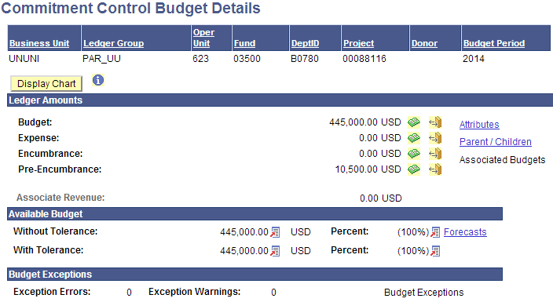  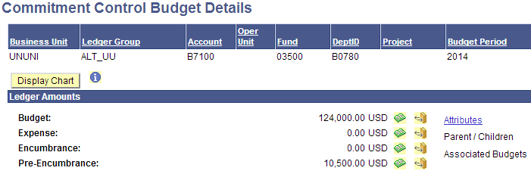

Purchase Order | Create PO
Navigation:  Purchasing > Purchase Orders > Add/Update POs  Create a PO under PO BU 623UU by copying the Req 623UU/#1 | 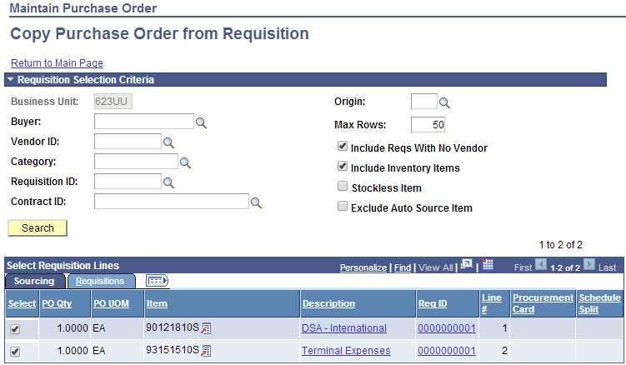  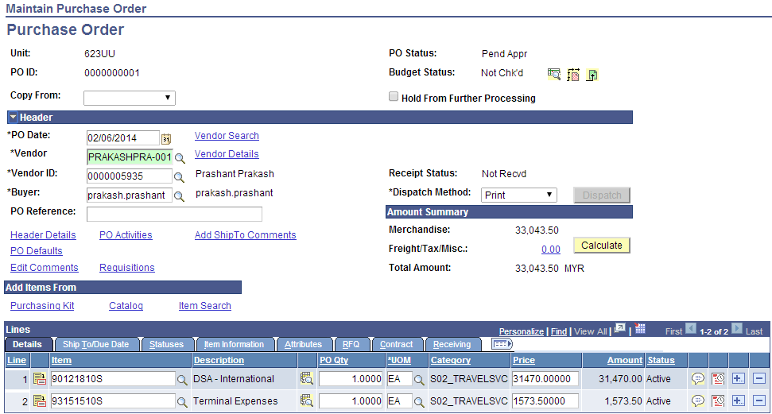
Approve and Budget Check the PO 623UU/#1  Review Level 2 Project Budgets.  Note the Encumbrance  Review Level 1 Budget Department Budget.  Note the Encumbrance | 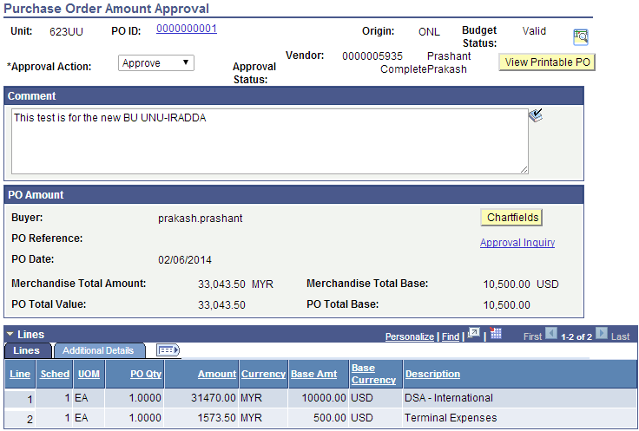  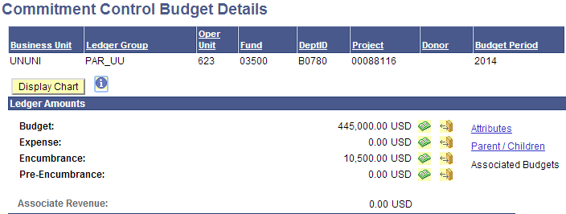  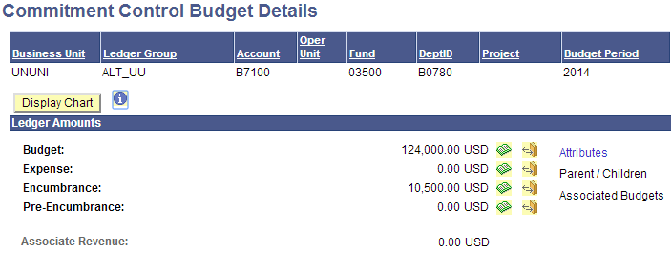
Dispatch the PO | 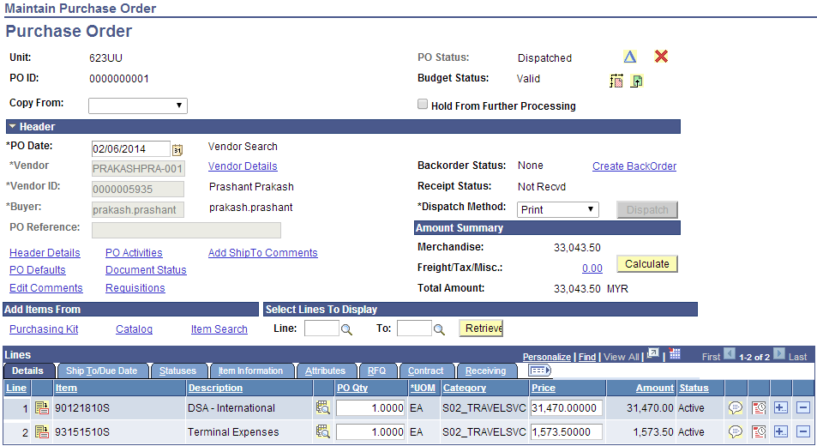  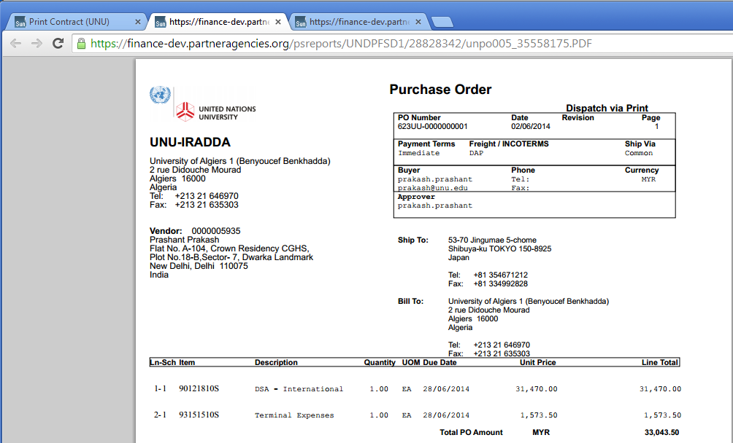

Voucher | Create Voucher
Navigation:  Accounts Payable > Vouchers >Add/Update > Regular Entry  Create a voucher under AP BU 623UU by copying the PO 623UU/#1 | 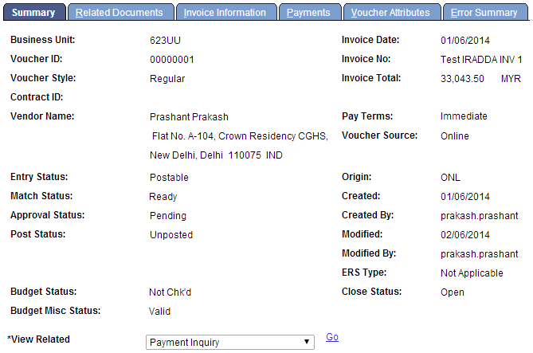  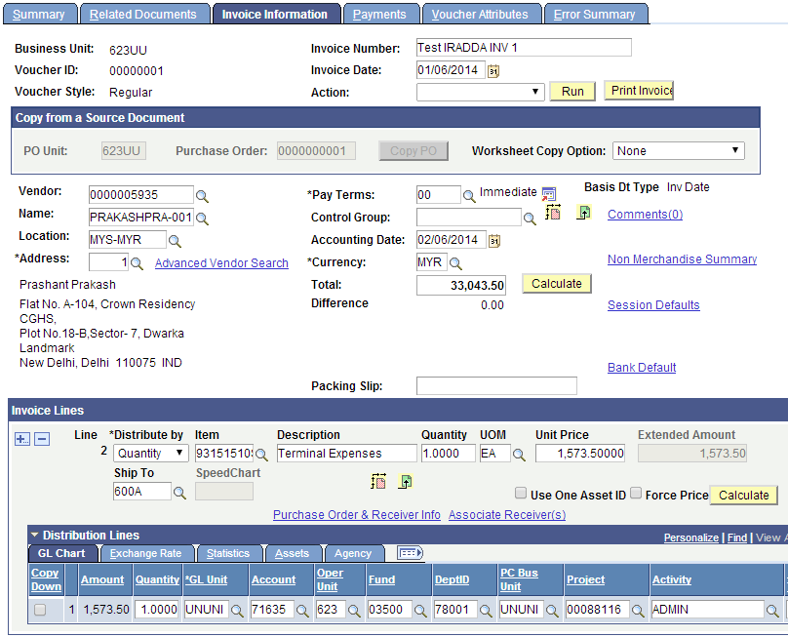
Match the Voucher | 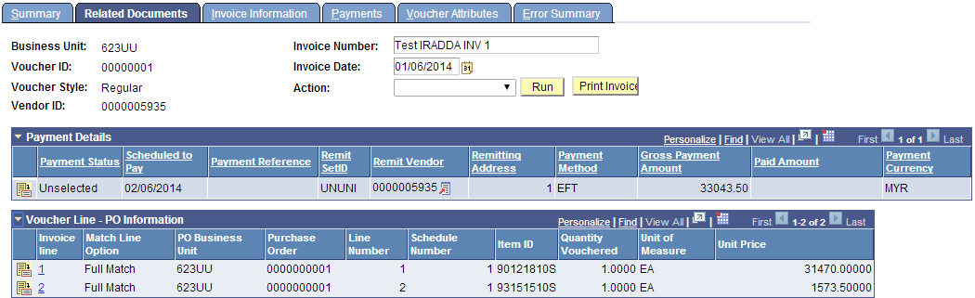  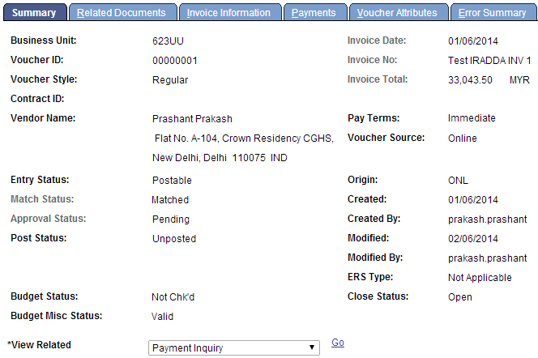

Online/Subsystem Journal | Journal
Navigation:  General Ledger > Journals >Journal Entry > Create/Update Journal Entries  Create an online journal for CoA belonging to UNU-IRADDA | 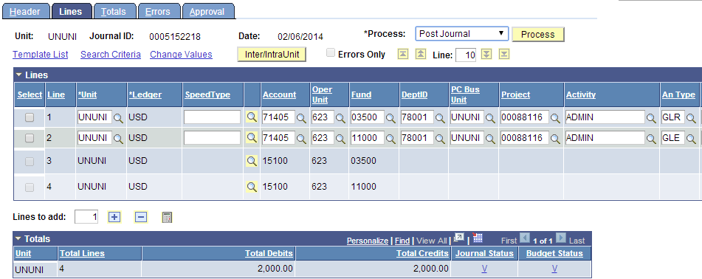  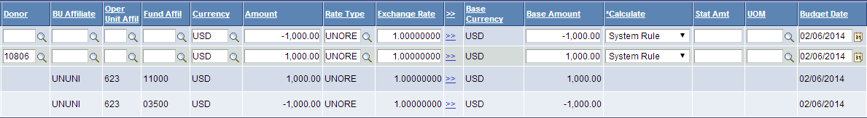  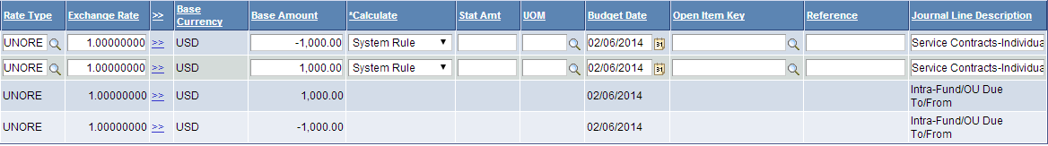
Post Subsystem and Online Journals to GL for UNU-IRADDA | 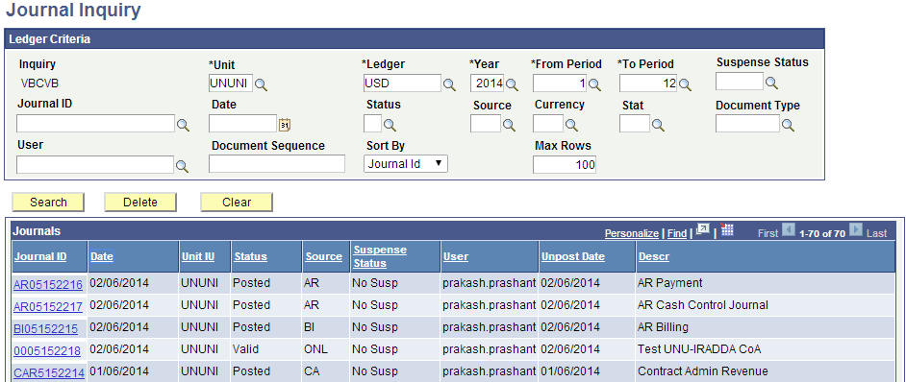
Verify Ledger Balances  *AP Subsystem journals have not been posted | 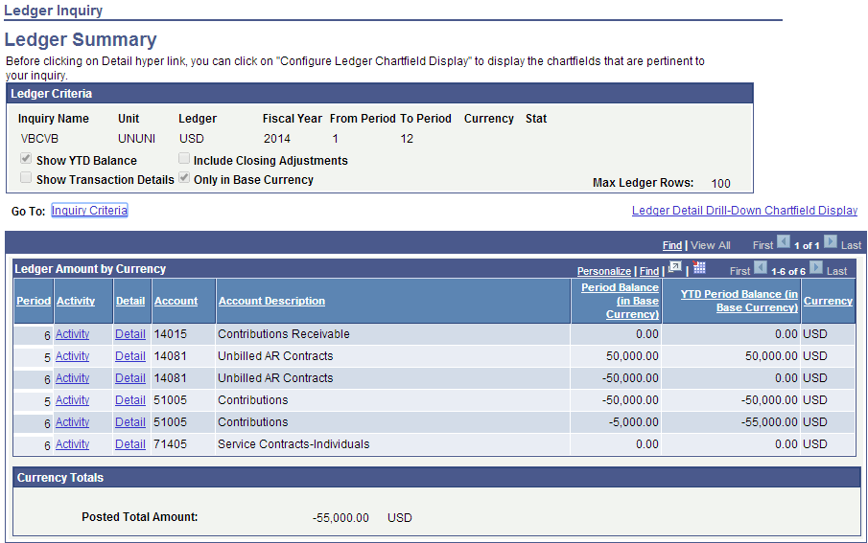

Revenue Testing | Post Budget Journal for AX1_UU
Navigation:  Commitment Control > Budget Journals > Enter Budget Journals  Create and Post a Budget Journal to initialize the following CF combination  Donor: 10806 – Algeria Govt  Fund Code – 11000  Project – 000881166  Journal has been posted successfully | 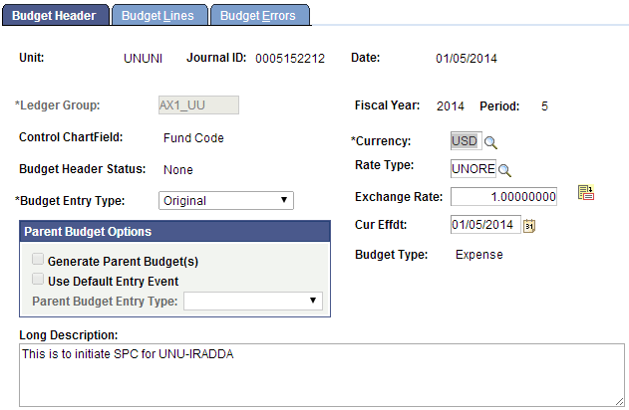  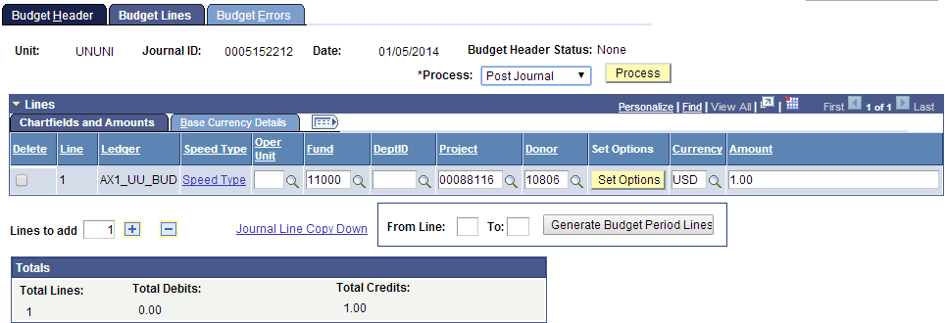  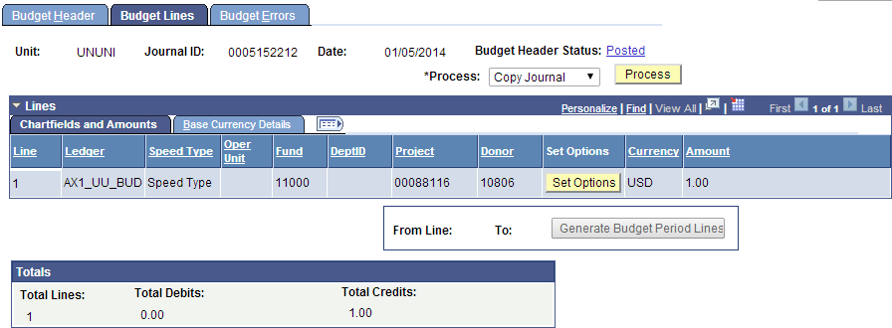
Verify Budget Details  Update Associated Budgets information  ***Now, post level 2 budget under Fund Code 11000 for this Project/Donor combination  This should be done after KK Revenue and Collected ledgers have been updated via Contracts/Billing and AR | 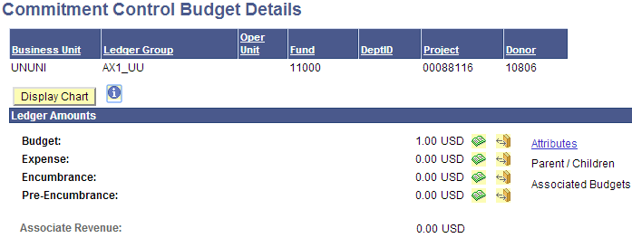  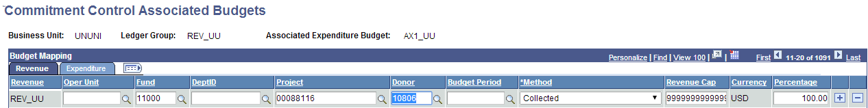  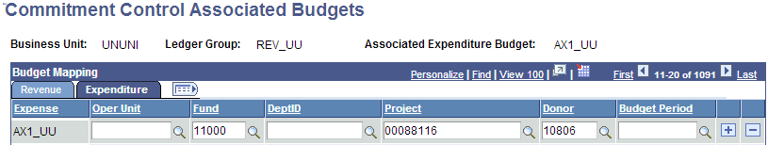  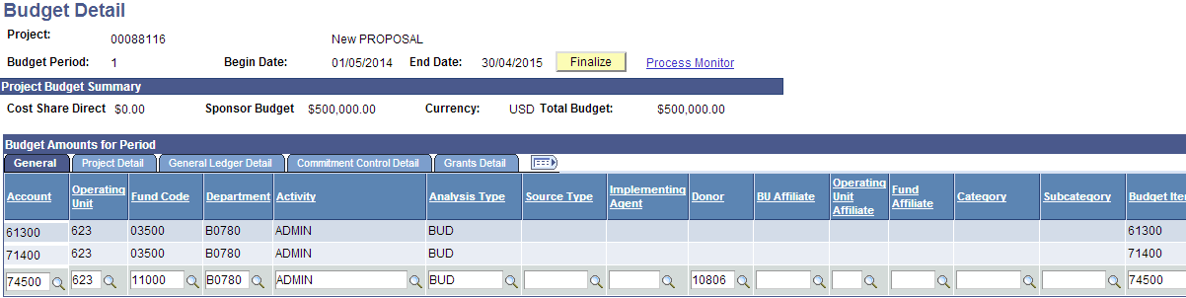  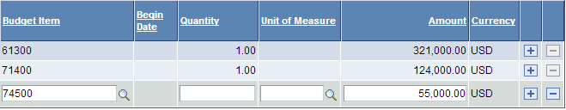  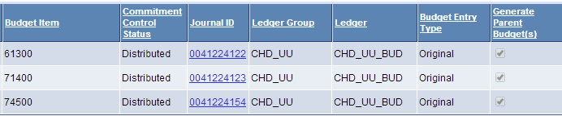

Revenue Testing | Create Contract
Create a contract for customer 10806 and process it.  Make sure KK Revenue and Collected Ledger Groups are updated | 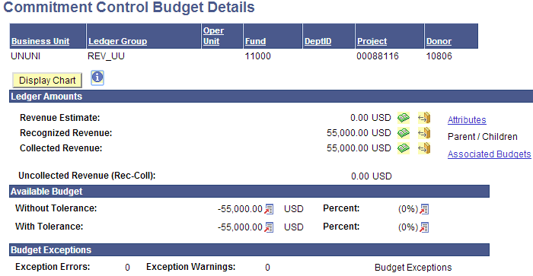  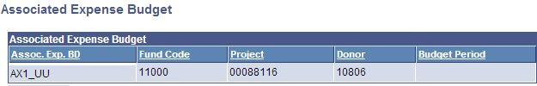  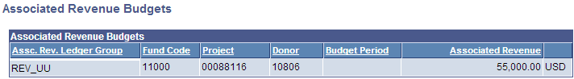
Create a Req to check the new combination  Create and Budget Check a PO for the new combination  Note the Cash Budget for this Donor/Project combination | 